**MARKET STOCK PRICE ANALYSIS BASED ON COMPANIES**

Previous literature on the topic already defined several proxies for assessing stock price crash risk. defines two different measures of crash propensity:

**NCSKEW and Down To Up Volatility.**

NCSKEW, which stands for “negative coefficient of skewness”,

allows us to compare the shape of the left (negative) tail of the distribution of returns to the shape of the right (positive) one and thus conclude that higher values of this indicator result in a longer left tail meaning that the stock is more prone to crash than another one with smaller left tail.

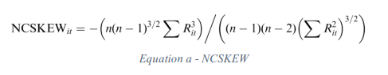

DUVOL (meaning “down-to-up volatility”) compares the magnitude of the returns below the period’s mean return to the magnitude of the returns above the mean return. It classifies these periods as “down” periods if their return in below the period average return and “up” periods if they are above. Once again, higher values on this indicator represent a more left-skewed distribution and thus, higher crash possibility.

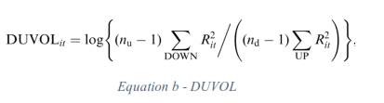

CRASH a binary variable (Dummy Variable) which takes the value 1 if, in that week, the return is 3.09 standard deviations below the yearly mean return and 0 if it is above that threshold. The **3.09** value regarding standard deviations is chosen in order to include the 0.1% of returns in each tail of an assumed normal distribution of that firm-stock returns meaning that, any observation included in those 0.1% are considered extreme events (whether a crash or a jump depending on which side it is located). Also with this variable, a higher value represents a higher crash frequency in the returns distribution.

**1--Stock Price Crash Determinants:**

The main goal of crash risk literature is trying to understand which factors influence stock price crashes. These factors can be grouped in distinct segments such as i) capital market related factors, ii) company related factors, iii) management related factors and iv) other factors.

Besides these previous major groups, there are other factors that are believed to influence stock price crash likelihood. Religion is appointed as a predictor for stock price crash. conclude that companies with headquarters located in counties with higher levels of religiosity present lower crash risk. Also, companies with institutional investors which have a stable presence in the company while conducting a monitoring role, have lower stock price crash risk. Companies where insiders have a higher proportion of ownership also tend to have lower future crashes.

By Using Stata we calculate the return of stock for each country (variable “id” in the dataset) and by date (variable “date2”). We used the formula of the return of the **Price** (variable “Price ” the dataset). Fore more details (see, Crash Risk.do file)

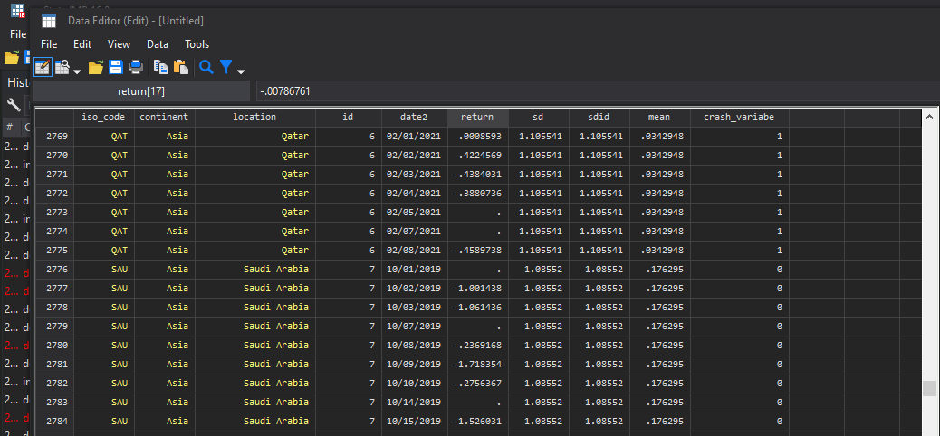

The result of the crash analysis sorted by (country and date)

The crash variable is measured as: An indicator variable that equals one if a stock experiences one or more stocks a returns exceeding 3.09 standard deviations below the mean stock a returns over the fiscal year and zero otherwise, with 3.09 chosen to generate frequencies of 0.1% in a normal distribution.

As you see in the capture Qatar had 1 as crash binary number (crash_variable) because it had the return below the yearly mean return of 3.09 standard deviations and 0 for Saudi Arabia.

**2--Negative Coefficient of Skewness (NCSKEW):**

To calculate NCSKEW we need a market index for each country, we calculate the market index index using volume (vol) of transaction for each country and by calculating the return of the market index (market_index). For more details (see, SKEWNESS.do file).

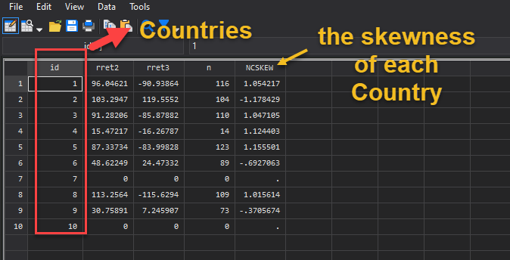

As you see the output we have the **NCSKEW** for each country.

**3--Stock Price Crash risk using down-to-up volatility (DUVOL):**

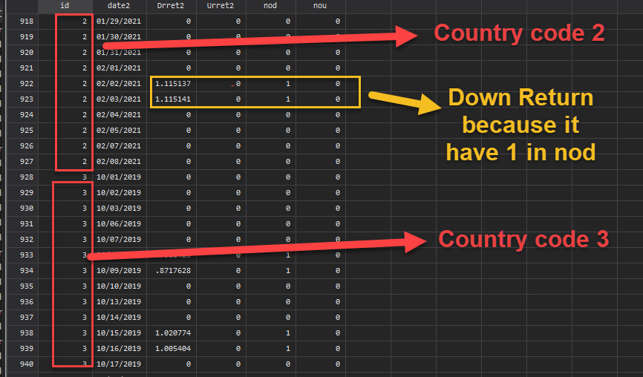

As you the in image for each period there is up and down return, when the return is above the annual mean the country has up return.

And if we want to see if a country made an Up or Down for the entire period of observation we can sort the analysis in stata by country. As you see in image the result according to each country.

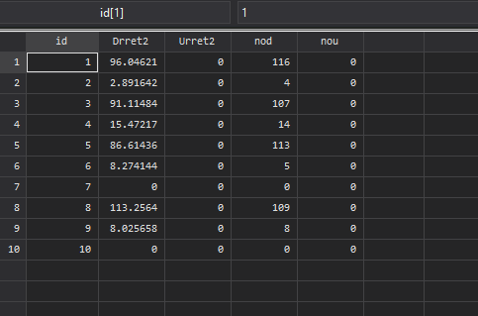

DATA ANALYSIS

describe

Contains data from E:\APP_WORKS\Data_Analysis_For_Stocks\datasetforlargesamplea

> nalysis\valuation_data.dta

obs: 37,106

vars: 76

size: 24,341,536

-------------------------------------------------------------------------------

storage display value

variable name type format label variable label

-------------------------------------------------------------------------------

permno double %8.0g PERMNO

date long %d Names Date

exchcd double %2.0g Exchange Code

siccd double %8.0g Standard Industrial

Classification Code

cusip str8 %8s CUSIP Header

ticker str8 %8s Ticker Symbol

comnam str36 %36s Company Name

tsymbol str10 %10s Trading Symbol

naics str8 %8s North American Industry

Classification System

trdstat str2 %2s Trading Status

beta double %12.0g

n double %12.0g

prc4 double %12.0g Price or Bid/Ask Average

ib_tic str6 %6s IBES Ticker Symbol

eps_1 double %12.0g Mean Estimate

eps_2 double %12.0g Mean Estimate

eps_3 double %12.0g Mean Estimate

eps_4 double %12.0g Mean Estimate

eps_5 double %12.0g Mean Estimate

eps_g double %12.0g Mean Estimate

dps_1 double %12.0g Mean Estimate

dps_2 double %12.0g Mean Estimate

dps_3 double %12.0g Mean Estimate

dps_4 double %12.0g Mean Estimate

dps_5 double %12.0g Mean Estimate

dps_g double %12.0g Mean Estimate

gvkey str6 %6s Global Company Key

datadate long %d Data Date

tic str8 %8s Ticker Symbol

conm str58 %58s Company Name

exchg double %6.0g Stock Exchange Code

cik str10 %10s CIK Number

costat str2 %2s Active/Inactive Status Marker

fyear double %6.0g Data Year - Fiscal

ajex double %18.0g Adjustment Factor (Company) -

Cumulative by Ex-Date

act double %18.0g Current Assets - Total

aqc double %18.0g Acquisitions

at double %18.0g Assets - Total

bkvlps double %18.0g Book Value Per Share

capx double %18.0g Capital Expenditures

ceq double %18.0g Common/Ordinary Equity - Total

che double %18.0g Cash and Short-Term Investments

csho double %18.0g Common Shares Outstanding

cshpri double %18.0g Common Shares Used to Calculate

Earnings Per Share - Basic

dlc double %18.0g Debt in Current Liabilities -

Total

dp double %18.0g Depreciation and Amortization

dpc double %18.0g Depreciation and Amortization

(Cash Flow)

dvc double %18.0g Dividends Common/Ordinary

epspx double %18.0g Earnings Per Share (Basic) -

Excluding Extraordinary Items

ib double %18.0g Income Before Extraordinary Items

invt double %18.0g Inventories - Total

ivch double %18.0g Increase in Investments

lct double %18.0g Current Liabilities - Total

ni double %18.0g Net Income (Loss)

sale double %18.0g Sales/Turnover (Net)

siv double %18.0g Sale of Investments

spi double %18.0g Special Items

txt double %18.0g Income Taxes - Total

xad double %18.0g Advertising Expense

xint double %18.0g Interest and Related Expense -

Total

xrd double %18.0g Research and Development Expense

prcc_c double %18.0g Price Close - Annual - Calendar

mkvalt double %18.0g Market Value - Total - Fiscal

sic str4 %4s Standard Industry Classification

Code

rank double %9.0g Rank - Auditor

au str8 %8s Auditor

auop str8 %8s Auditor Opinion

auopic str2 %2s Auditor Opinion - Internal

Control

ap double %18.0g Accounts Payable - Trade

fincf double %18.0g Financing Activities - Net Cash

Flow

gdwl double %18.0g Goodwill

intan double %18.0g Intangible Assets - Total

ivncf double %18.0g Investing Activities - Net Cash

Flow

oancf double %18.0g Operating Activities - Net Cash

Flow

ppegt double %18.0g Property, Plant and Equipment -

Total (Gross)

rect double %18.0g Receivables - Total

-------------------------------------------------------------------------------

Sorted by:

.

. summarize beta prc4 exchcd n eps_1 eps_1 eps_3 dps_3 dps_4 dps_5 dps_g

Variable | Obs Mean Std. Dev. Min Max

-------------+---------------------------------------------------------

beta | 37,106 1.281538 .7864947 -18.22339 9.013506

prc4 | 37,106 30.22909 43.36951 .0376 1661.29

exchcd | 37,106 2.047378 .9845965 1 4

n | 37,106 57.06689 8.036589 24 60

eps_1 | 37,106 -90.27023 8544.74 -975000 338625

-------------+---------------------------------------------------------

eps_1 | 37,106 -90.27023 8544.74 -975000 338625

eps_3 | 22,542 -47.30604 6055.824 -791666.7 51600

dps_3 | 16,312 .8736629 2.604806 0 160

dps_4 | 4,924 1.46107 3.759334 0 117

dps_5 | 3,394 2.111709 30.45265 0 1761

-------------+---------------------------------------------------------

dps_g | 2,510 9.45543 12.62465 -6.54 236

.

## 2.1 Relation between Accounting Numbers and Stock Prices

The accounting net income (NI) of a firm, often referred to as earnings, is the “bottom line” in financial statements and a measure of firm performance. Earnings numbers measure the financial performance of a firm over a specified period and are, unlike cash flows, accrual based. In theory, NI symbolizes a change in value to common equity holders (Nichols and Wahlen 2004). Beaver (1998) developed three links through which earnings are directly related to intrinsic equity value in theory. First, reported earnings provide information about current as well as expected future profitability. Second, expected future profitability provides useful information to forecast expected future dividends. Finally, expected future dividends can be discounted to determine an intrinsic equity value.

Earnings are usually considered as the most relevant information of financial statements and hence, many equity valuation models use expected earnings as the explanatory variable (Lev 1989). Already Miller and Modigliani (1966) used expected earnings to estimate the cost of capital for the electric utility industry. However, Lev (1989) raised the question if earnings are useful to investors and contain relevant information.

Ball and Brown (1968) provided the first empirical research about the relative importance of NI. They found that stock prices react to differences between actual income numbers and expected income in the same direction. However, most of the information contained in the reported income is already incorporated in the stock price during the period prior to the announcement. Beaver (1968) observed stock prices and trading volumes around the earnings announcement periods. He discovered above normal price reactions and trading volumes around the announcement date, which is consistent with the contention that earnings include relevant information. Moreover, he provided evidence that earnings announcements let not only individual investors alter investment decisions but also change the entire market expectation. In addition, he observed lower trading volume prior to the announcement indicating that investors postpone trading decisions until the information release.

While those two papers represent the first empirical research attempts in this topic, Nichols and Wahlen (2004) provided more recent evidence on the connection between earnings and share price. They found that firms with increasing earnings experience higher abnormal stock returns than firms with decreasing earnings. More importantly, they discovered that earnings provide more value-relevant information than operational cash flows indicating that accrual accounting contains value relevant information.

However, there is criticism regarding the use of earnings in valuation. Lev (1989) argued that earnings have relatively low explanatory power for stock returns given several reasons including investor irrationality but also low information content of earnings. The low quality of earnings may be a result of data manipulation by managers as well as biases induced by valuation principles and accounting measurement.

## 2.2 Equity valuation principles

Since maximizing firm value is still considered as a main goal of managers, valuing a firm and correspondingly its equity is of interest for nearly every business decision inside a company. In addition, outside of a company, investors and their security analysts or credit analysts as well as potential acquirers are particularly interested in a firm´s valuation in order to support investment or acquisition decisions (Palepu, Healy et al. 2013).

According to Palepu, Healy et al. (2013) “Valuation is the process of converting a forecast into an estimate of the value of the firm´s assets or equity.” However, many different valuation methods exist, and the question arises, which of the methods are the most appropriate to use. The different methods can mainly be separated into two approaches: FBVMs and MBVMs. FBVMs discount forecasted future accounting flows to estimate the intrinsic value of equity. On the contrary, MBVMs use a performance measure as a value driver of the firm and multiply it with a price multiple derived from comparable firms (Palepu, Healy et al. 2013). Theoretically, the accounting flows must be forecasted to infinity to come to the same valuation for the FBVMs (Penman and Sougiannis 1998). However, only an analysis over a finite horizon is practical which causes differences in the valuation.

### 2.2.1 Equity and entity perspective

For all valuation approaches two different perspectives of valuation exist: equity and entity perspective. The equity perspective directly evaluates shareholder´s value of equity claims (Palepu, Healy et al. 2013). However, in a world with taxes, cost of financial distress and other agency costs different capital structures affect the value of a firm and hence also equity value. Valuing all operating and investment assets of the firm (entity perspective) meaning the claims of equity holders as well as debt holders is therefore less affected by decisions regarding the capital structure. Generally, the relation between equity- and entity value can be described as followed (Schreiner and Spremann 2007):

𝑉𝑒𝑛𝑡𝑖𝑡𝑦 = 𝑉𝑒𝑞𝑢𝑖𝑡𝑦 + 𝑉𝑛𝑒𝑡 𝑑𝑒𝑏𝑡 (1)

𝑉𝑛𝑒𝑡 𝑑𝑒𝑏𝑡 = 𝑉𝑡𝑜𝑡𝑎𝑙 𝑑𝑒𝑏𝑡 − 𝑉𝑐𝑎𝑠ℎ & 𝑐𝑎𝑠ℎ 𝑒𝑞𝑢𝑖𝑣𝑎𝑙𝑒𝑛𝑡𝑠 + 𝑉𝑝𝑟𝑒𝑓𝑒𝑟𝑟𝑒𝑑 𝑠𝑡𝑜𝑐𝑘 (2)

where

|  |  |
| --- | --- |
| *Ventity* | Enterprise value |
| *Vequity* | Market value of common equity |
| *Vnet debt* | Market value of net debt |
| *Vtotal debt* | Market value of total debt |
| *Vcash & cash equivalents* | Market value of cash and cash equivalents |
| *Vpreferred stock* | Market value of preferred stock |

In theory, both perspectives lead to the same result, but there are implementation issues which affect practical performances (Palepu, Healy et al. 2013). The entity value cannot be observed since debt is usually not stated as market value and is approximated by book values. Especially interest rate changes and default risk developments but also differences in accounting practices can create large variations in such approximation (Schreiner and Spremann 2007).

Given those implementation issues, this dissertation only considers the equity perspective for simplification reasons. In a next step, three different FBVMs and one MBVM are introduced and their advantages as well as disadvantages are discussed.

## 2.3 Flows-based Model

### 2.3.1 Dividend Discount Model

In theory, the value of a financial asset is the present value of the net cash flows generated by the asset. The dividend discount model (DDM) follows the assumption that the cash payoffs ultimately received by shareholders for their equity claims are the dividends paid by the firm. Therefore, the present value of all expected future dividends represents the value of equity (Palepu, Healy et al. 2013):

𝑉𝑡𝑒 = 𝐸𝑡[1𝐷𝐼𝑉+𝑟𝑡𝑒+1] + 𝐸𝑡([1𝐷𝐼𝑉+𝑟𝑒𝑡)+22] + 𝐸𝑡([1𝐷𝐼𝑉+𝑟𝑒𝑡)+33] + ⋯ (3) where

|  |  |
| --- | --- |
| *Vte* | Present value of all future dividends |
| *Et[DIVt+1]* | Expected dividend paid in one year from now |
| *re* | Cost of equity which is the relevant discount rate that represents the riskiness of expected dividends |

Equation (3) assumes an infinite lifetime of the firm, but this might not be true e.g. if the firm goes bankrupt. In addition, this assumption is impractical as it is more difficult to forecast longer horizons. Assuming a constant growth rate *g* of future dividends in perpetuity simplifies the equation (Palepu, Healy et al. 2013):

𝑉𝑡𝑒 = 𝐸𝑡[𝑟𝐷𝐼𝑉𝑒−𝑔𝑡+1] (4)

Combining equation (3) and (4) and assuming dividends will grow at a constant rate after two years from now allows to shorten the forecasting period (Palepu, Healy et al. 2013):

𝐸𝑡[𝐷𝐼𝑉𝑡+2]×(1+𝑔)

𝑟

𝑒

−

𝑔

𝑉𝑡𝑒 = 𝐸𝑡[1𝐷𝐼𝑉+𝑟𝑡𝑒+1] + 𝐸𝑡([1𝐷𝐼𝑉+𝑟𝑒𝑡)+22] + (1+𝑟𝑒)2 (5)

Now, the constant growth model represents a terminal value (TV), which simplifies the model and allows analysts to forecast short-term or medium-term dividends.

The implementation of a DDM is rather simple given its basis that dividends are the ultimate cash flows to shareholders. In addition, it is practical to apply for mature firms, which pay stable dividends as those are easier to forecast. However, the model is limited to dividend paying firms but the amount of dividends paid highly depends on a firm´s investment opportunities (Palepu, Healy et al. 2013). Thus, start-ups or quickly developing firms, which require capital and do not pay dividends, cannot be valued with a DDM. In addition, Ball and Brown (1968) provided evidence for a connection between NI and stock price returns. Nevertheless, dividends may not be perfectly linked to earnings since also firms with negative earnings pay dividends, which may decrease the accuracy of the DDM. Moreover, Francis, Olsson et al. (2000) discovered a high dependence on the TV in this model. Hence, changes in the estimates of the constant growth rate *g* and/or the cost of equity *re* result in large changes in the TV and correspondingly in the equity value estimate. Given this sensitivity, difficulties in estimating *g* and *re* accurately have a large impact on the accuracy of the value estimate. Furthermore, the assumption of a constant perpetual growth rate of the dividends is often unrealistic.

### 2.3.2 Discounted Free Cash Flow Model

The discounted free cash flow model (DFCFM) follows the same basic theory for the value of financial claims – present value of future net cash flows – as the DDM. However, the corresponding accounting flow differs. Instead of discounting dividends, free cash flows either to equity (FCFE) or to entity/firm (FCFF) are considered. As mentioned earlier, this dissertation focuses only on the equity perspective and thus only FCFE is considered, which is also important for choosing the correct discount rate. FCFE is the cash flow remaining after meeting all debt payments and investment needs and thus is the amount available to be distributed to shareholders (Damodaran 2010). Thus, this approach tries to account for the fact that many firms do not pay any dividends although they create sufficient FCFE. Over the entire lifetime of a firm, total FCFE and dividends should be the same under the assumption, that all FCFE are ultimately distributed to shareholders.

The FCFE for a period *t* can be calculated by adjusting NI for all non-expense cash outflows and all non-cash earnings (Palepu, Healy et al. 2013):

𝐹𝐶𝐹𝐸𝑡 = 𝑁𝐼𝑡 + 𝐷&𝐴𝑡 − 𝐶𝐴𝑃𝐸𝑋𝑡 − Δ𝑊𝐶𝑡 + Δ𝐵𝑉𝐷𝑡 (6)

where

|  |  |
| --- | --- |
| *NIt* | Net income during period *t* |
| *D&At* | Depreciation and amortization expense (D&A) during period *t* |
| *CAPEXt* | Capital expenditure during period *t* |
| *ΔWCt* | Change in working capital (WC) during period *t* |
| *ΔBVDt* | Change in book value of debt (BVD) during period *t* |

Using again the assumption of a constant growth rate after two years, results in following calculation of the intrinsic value of equity (Palepu, Healy et al. 2013):

𝐸𝑡[𝐹𝐶𝐹𝐸𝑡+2]×(1+𝑔)

𝑉𝑡𝑒 = 𝐸𝑡[𝐹1𝐶𝐹𝐸+𝑟𝑒𝑡+1] + 𝐸𝑡[(𝐹𝐶𝐹𝐸1+𝑟𝑒)𝑡2+2] + (1+−𝑟𝑒𝑔)2 (7)

𝑟

𝑒

The DFCFM overcomes the implementation issue of the DDM that it is also applicable for non-dividend paying firms. Additionally, as it focuses on cash flows, that are available for distribution to shareholders and not only on dividends, it is a less conservative approach and is expected to generate a more accurate estimate (Damodaran 2010). Moreover, FCFE are less discretionary than earnings and thus overcome the issue of possible earnings manipulation mentioned by Lev (1989). Analysts seem to recognize those advantages as the DFCFM is widely used in the financial industry (Hand, Coyne et al. 2017).

However, like the DDM, DFCFM is very sensitive to assumptions about the input factors given the high dependence on TV (Francis, Olsson et al. 2000). Moreover, forecasting FCFE can cause difficulties whenever items such as working capital are difficult to identify or financial leverage is likely to change over time (Damodaran 2010).

### 2.3.3 Residual Income Valuation Model

Although the residual income valuation model (RIVM) has not recently been developed (Preinreich 1938), it is often attributed to the rediscovery by Ohlson (1995). The model assumes that earnings, dividends, and book value of equity (BVE) are connected through the clean surplus relation (CSR):

Δ𝐵𝑉𝐸𝑡 = 𝑁𝐼𝑡 − 𝐷𝐼𝑉𝑡 (8)

𝐷𝐼𝑉𝑡 = 𝑁𝐼𝑡 + 𝐵𝑉𝐸𝑡−1 − 𝐵𝑉𝐸𝑡 (9)

where

|  |  |
| --- | --- |
| *DIVt* | Dividend paid (net of capital distributions) during period *t* |
| *NIt* | Net income during period *t* |
| *ΔBVEt* | Change in BVE over the period *t* |

The CSR holds, if all changes in assets and liabilities unrelated to dividends go through the income statement. Replacing dividends in (3) of the DDM results in:

𝑉𝑡𝑒 = 𝐸𝑡[𝑁𝐼𝑡+1]+1𝐵𝑉𝐸+𝑟𝑒𝑡−𝐵𝑉𝐸𝑡+1 + 𝐸𝑡[𝑁𝐼𝑡+2]+(1𝐵𝑉𝐸+𝑟𝑒𝑡)+21−𝐵𝑉𝐸𝑡+2 + 𝐸𝑡[𝑁𝐼𝑡+3]+(1𝐵𝑉𝐸+𝑟𝑒𝑡)+32−𝐵𝑉𝐸𝑡+3 + ⋯ (10)

Which can be reformulated as:

𝑉𝑡𝑒 = 𝐵𝑉𝐸𝑡 + 𝐸𝑡[𝑁𝐼𝑡+11+]−𝑟𝑟𝑒𝑒×𝐵𝑉𝐸𝑡 + 𝐸𝑡[𝑁𝐼𝑡+(21]+−𝑟𝑟𝑒𝑒)×2𝐵𝑉𝐸𝑡+1 + 𝐸𝑡[𝑁𝐼𝑡+(31]+−𝑟𝑟𝑒𝑒)×3𝐵𝑉𝐸𝑡+2 + ⋯ (11)

The numerator in each fraction represents the expected residual income (RI) for each period. It is the difference of expected earnings and required earnings calculated as the product of a required return and the BVE at the beginning of the period (Ohlson 1995). Assuming RI will grow at a constant rate *g* after two years results in following equation including a TV:

𝐸𝑡[𝑅𝐼𝑡+2]×(1+g)

𝑟

𝑒

−

𝑔

𝑉𝑡𝑒 = BVE𝑡 + 𝐸𝑡1[𝑅𝐼+𝑟𝑡+𝑒 1] + 𝐸(𝑡1[+𝑅𝐼𝑟𝑡𝑒+)22] + (1+𝑟𝑒)2  (12)

The value created by RI represents the difference between BVE and market value of equity known as goodwill (Ohlson 1995). The rationale behind the RIVM is to focus on earnings rather than cash flows because they are the “bottom-line” in financial statements and the primary performance measure of a firm. Additionally, earnings include accruals and hence, take into account additional performance information, that cash flows cannot capture (Nichols and Wahlen 2004). This advantage can be misused and potential managerial discretionary or manipulation can lead to a less reliable value estimate. However, Francis, Olsson et al. (2000) argued that empirically the RIVM is resistant to variations in companies´ accounting policies and practices. Courteau, Kao et al. (2015) analyzed the impact of a new U.S. accounting regulation in 2002 on the performance of RIVM and DFCFM. They found that earnings management indeed affected the performance of RIVM prior to that regulation. However, post the regulation RIVM outperforms DFCFM also for firms with potential earnings management. Francis, Olsson et al. (2000) as well as Penman and Sougiannis (1998) found a main advantage of RIVM that the TV represents only a small portion of the value estimate. A large portion is captured by BVE making the estimate less sensitive to assumptions regarding the cost of equity and the long-term growth rate. Thus, they argued that the RIVM generates a more reliable estimate.

Nevertheless, in practice CSR might not hold. Lo and Lys (2000) discovered that a significant number of companies which use US GAAP as accounting standard violate CSR historically. Main reason for this is that besides NI other comprehensive income affects the change in BVE (Spiceland, Sepe et al. 2013). However, Lo and Lys (2000) also stated that CSR must only hold for expected future values.

## 2.4 Multiples-based Model

MBVMs are widely used among practitioners. 99.1% of analysts use some kind of earnings multiple in their valuation process (Asquith, Mikhail et al. 2005). This popularity is among other reasons given by the simplicity of the concept of MBVMs. It is very easy to understand and to calculate (Fernandez 2001). Unlike FBVMs, this approach does not require to forecast accounting flows and to calculate the present value using an estimated required return. MBVMs follow the assumption that the ratio of the price and a performance measure of the firm being valued will revert to a benchmark ratio (Courteau, Kao et al. 2006). Thus, in MBVMs a performance measure is chosen as a value driver and multiplied by a corresponding multiple of comparable firms (Liu, Nissim et al. 2007):

𝑉𝑖𝑒 = 𝑉𝐷𝑖 × 𝐵𝑒𝑛𝑐ℎ𝑚𝑎𝑟𝑘𝑀𝑢𝑙𝑡𝑖𝑝𝑙𝑒𝑖(Φ𝑖) (13)

where

|  |  |
| --- | --- |
| *Vie* | Estimated intrinsic value of equity of firm *i* |
| *VDi* | Value driver of firm *i* |
| *Φi* | Set of *n* comparable firms for firm *i* |

To calculate the benchmark multiple, a multiple for each comparable firm is calculated as followed:

𝑃𝑗

𝑀𝑢𝑙𝑡𝑖𝑝𝑙𝑒 = (14)

𝑉𝐷𝑗

Where

|  |  |
| --- | --- |
| *Pj* | Observed share price |
| *VDi* | Value driver of the *jth* comparable firm with *j*=1,2,…,*n* |

Using the multiples calculated for comparable firms, a benchmark multiple can be determined. For this, analysts often use the mean or median but there are also other methods which can affect the accuracy of valuation (Liu, Nissim et al. 2007).

Therefore, this valuation method requires three main decisions (Baker and Ruback 1999):

1. Choice of the value driver
2. Choice of the comparable firms
3. Choice of the calculation method of the benchmark multiple

Since MBVMs rely on the current valuation of comparable firms, they have the ability to capture the current mood of stock markets better than FBVMs (Baker and Ruback 1999). However, this advantage can cause issues at the same time. If the chosen comparable firms – e.g. industry – are over- or undervalued, the value estimates are distorted in the same direction.

### 2.4.1 Choice of the value driver

Many different multiples using a wide range of value drivers exist. According to Fernandez (2001) the most commonly used ones are the price earnings ratio (PER) and enterprise value to EBITDA (EV/EBITDA) multiple. The choice of the value driver directly affects the value estimate and thus should be done carefully. No basic rules apply, which determine the correct value driver and they may perform best for different firms and industries (Kim and Ritter 1999). The value driver only needs to satisfy two conditions:

Since negative equity values do not exist, the value driver must take a positive value (Liu, Nissim et al. 2007). Moreover, the value driver should be proportional to the stock price.

According to Nichols and Wahlen (2004) earnings contain more value relevant information than cash flows because accruals contain additional information about profitability and wealth creation. Hence, multiples including earnings rather than cash flows should result in a more accurate value estimate. Nevertheless, Beaver and Morse (1978) argued that accounting methods regarding accruals or transitory items cause differences in PER. To circumvent such issues, rather forecasted instead of realized earnings should be used. Several studies found that forecasted earnings improve the accuracy of MBVMs (Kim and Ritter 1999, Lie and Lie 2002, Liu, Nissim et al. 2002).

Liu, Nissim et al. (2002) compared the valuation performance of a wide range of multiples using different value drivers. They found that using a multiple horizon forecast can even improve the accuracy of the value estimate. Furthermore, they showed that realized earnings multiples perform better than realized cash flow multiples illustrating the value relevant information contained in accruals. In a more specific analysis a few years later, they showed that this is also the case for forecasted value drivers and argue that earnings indicate changes in value independent from incoming cash flows (Liu, Nissim et al. 2007). Finally, they argued that forecasted earnings multiples perform best among all analyzed industries rejecting the hypothesis that in different industries different multiples perform best.

To conclude, although it is argued that accruals can be used for earnings manipulation and require managerial discretion, empirical evidence suggest that a forecasted earnings multiple performs best among MBVMs (Liu, Nissim et al. 2007).

### 2.4.2 Choice of the comparable firms

Different studies have shown that the level of comparability of the firm being valued and the comparable firms affect the accuracy of the value estimate using a MBVM (Boatsman and Baskin 1981, Alford 1992, Bhojraj and Lee 2002). The benchmark multiple calculated from comparable firms should be similar to the unknown multiple of the firm being valued (Alford 1992). First it is questioned if only one comparable firm or a group of comparable firms should be used. Since multiples can vary a lot among different companies, using a group as peer can reduce the effect of outliers and hence lead on average to a more accurate value estimate. However, if only one comparable firm is chosen which is the most similar to the firm being valued, the value estimate in that specific case can be the most accurate.

Choosing the industry as peer group seems reasonable and is found to be an effective approach. Alford (1992) discovered that choosing the peer group by industry results in similar accuracy as selecting the comparable firms based on risk and earnings growth, suggesting that the industry can capture those two properties. However, adjusting for leverage decreases accuracy. Boatsman and Baskin (1981) compared the value estimate using a PER but two different comparable firms. They found that the value estimate was more accurate when the comparable firm was specifically chosen from the industry based on the most similar ten-year earnings growth rate instead of randomly choosing an industry member. On the contrary, Alford (1992) could not find improvements of dividing the industry by earnings growth which supports the idea of using a group of firms can reduce the effect of outliers. Besides similar economic characteristics, Young and Zeng (2015) argued that the comparability of accounting increases the accuracy of MBVMs and thus needs to be considered in peer selection.

Bhojraj and Lee (2002) developed a different approach for selecting a peer group. They argued that selecting comparable firms based on a “warranted multiple” which is estimated by using variables that affect the value driver – e.g. expected profitability or growth – results in a more accurate value estimate than the selection simply based on the industry. Hence, they focused on choosing firms that are similar regarding profitability, risk characteristics and growth. This should circumvent the issue that the industry may not always be concretely defined.

The correct choice of comparable firms is a crucial factor in MBVMs since it significantly affects the accuracy of the value estimate. Difficulties in the selection process can cause the value estimate to be imprecise.

### 2.4.3 Choice of the calculation method of the benchmark multiple

After calculating the chosen multiple for each of the chosen comparable firms, the benchmark multiple can be calculated. Hereby, the choice of the averaging technique matters as it has a large impact on the results (Agrrawal, Borgman et al. 2010). Besides using the arithmetic mean, value-weighted mean, median, and the harmonic mean can be used (Baker and Ruback 1999):

𝑎𝑟𝑖𝑡ℎ𝑚𝑒𝑡𝑖𝑐 𝑚𝑒𝑎𝑛 𝑛 𝑛𝑗=1 𝑉𝐷𝑃𝑗𝑗 (15)

∑𝑛𝑗=1 𝑃𝑗

𝑣𝑎𝑙𝑢𝑒 − 𝑤𝑒𝑖𝑔𝑡ℎ𝑒𝑑 𝑚𝑒𝑎𝑛 = 𝑛  (16)

∑𝑗=1 𝑉𝐷𝑗

𝑃𝑗

𝑚𝑒𝑑𝑖𝑎𝑛 = 𝑚𝑒𝑑𝑖𝑎𝑛() (17)

𝑉𝐷𝑗

𝑛 ℎ𝑎𝑟𝑚𝑜𝑛𝑖𝑐 𝑚𝑒𝑎𝑛 = 𝑉𝐷𝑗 (18)

∑𝑗𝑛=1 𝑃𝑗

where

|  |  |
| --- | --- |
| *n* | Number of comparable firms |
| *VDj* | Value driver of the *jth* comparable firm |
| *Pj* | Observed share price |

Although averaging is often considered as using the arithmetic mean, this method does not adjust for outliers leading to an upwards biased valuation (Agrrawal, Borgman et al. 2010). To overcome such upwards bias, Damodaran (2016) proposed to use either the median, an aggregate multiple, or the inverse of a multiple, which is the harmonic mean. Baker and Ruback (1999) suggested that the harmonic mean is the best estimator because increasing prices tend to increase pricing errors. They argued that the harmonic mean is mathematically always smaller than the arithmetic mean and thus is less upwards-biased. In addition, a small value driver yields a large multiple, which the harmonic mean circumvents. Liu, Nissim et al. (2002) found similar results indicating that the harmonic mean results in more accurate value estimates than the arithmetic mean or median. Schreiner´s and Spremann´s (2007) superior results of using the median indicate that besides the harmonic mean, the median is an appropriate method, as well.

## 2.5 Empirical evaluation of different valuation methods

Equity valuation based on accounting numbers has been discussed by accounting researches as well as practitioners intensely. The discussion about FBVMs has intensified especially after the rediscovery of the RIVM by Ohlson (1995). Frankel and Lee (1998) observed a high correlation of a value estimate using the RIVM and stock prices. They found that a ratio of this estimate to price has the ability to predict long-term cross-sectional returns and captures effects, which cannot be explained by other common information such as a book-to-market ratio or beta. Penman and Sougiannis (1998) as well as Francis, Olsson et al. (2000) compared the performance in value estimation of DDM, DFCFM, and RIVM in a LSA. Despite the theoretical equivalence of the three models, they found a superiority in accuracy of RIVM. They named the lower portion of TV in the RIVM (Francis, Olsson et al. 2000) and the additional information of earnings using accruals (Penman and Sougiannis 1998) as major reasons for this superiority. However, as a response to those findings Lundholm and O'keefe (2001) argued, that three implementation errors were made causing such inequivalences of RIVM and DFCFM. Empirical evidence on the equivalence of RIVM and DFCFM was provided by Courteau, Kao et al. (2001), which analyzed the differences in DFCFM and RIVM including theoretical “ideal” TVs. However, they state, that if those “ideal” values are not available RIVM is superior to DFCFM supporting the findings of Penman and Sougiannis (1998) and Francis, Olsson et al. (2000).

Besides, MBVMs have been analyzed by researches, as well. Schreiner and Spremann (2007) analyzed European equity markets and found that multiples using the equity perspective outperform multiples using the entity perspective. Liu, Nissim et al. (2002) compared the performance of different multiples and discovered that price to forward earnings ratios outperform all other common multiples in equity valuation. They supported this finding themselves with a second study only comparing forward earnings with forward cash flows as value drivers (Liu, Nissim et al. 2007). They conclude that earnings outperform other value drivers since they include more value-relevant information through accruals. The discovery that forecasted value drivers outperform historical ones was also found by several other studies (Kim and Ritter 1999, Lie and Lie 2002, Schreiner and Spremann 2007).

The research on the direct comparison of the performance of MBVMs and FBVMs is rather limited. Lee and Swaminathan (1999) created a RIVM estimate to price multiple and found a superiority compared to the inverses of common multiples such as PER or market-to-book in predicting overall returns of the Dow Jones index. Kaplan and Ruback (1995) found that DFCFMs lead to reliable estimates in valuing firms as part of highly levered transactions. They argued that a DFCFM performs at least as well as MBVMs. Courteau, Kao et al. (2006) compared value estimates of RIVM to a MBVM using a forward PER as value driver. They found an outperformance of the RIVM, meaning lower pricing errors and a higher ability to predict returns. Furthermore, they suggested that a combination of both value estimates using equal weights results in the most accurate valuation.